**ONLINE INSPECTION OF PACKED CASES**

## A PROJECT REPORT

***Submitted by,***

**B. HARINATH REDDY - 20211CSE0845**

**D. LAXMI NIRANJAN REDDY - 20211CSE0838**

**N. PAVAN KUMAR - 20211CSE0839**

**D. SAI ESWARA REDDY - 20211CSE0516**

**K. DINESH - 20211CSE0709**

### *Under the guidance of,*

**Dr./Mr./Ms./Prof. SUKRUTH GOWDA**

**Professor / Associate Professor / Assistant Professor**

**School of Computer Science and Engineering**

**Presidency University**

***in partial fulfillment for the award of the degree of***

**BACHELOR OF TECHNOLOGY**

**IN**

**COMPUTER SCIENCE AND ENGINEERING**

**At**



**PRESIDENCY UNIVERSITY**

**BENGALURU**

**PRESIDENCY UNIVERSITY**

**SCHOOL OF COMPUTER SCIENCE ENGINEERING**

**CERTIFICATE**

This is to certify that the Project report **“ONLINE INSPECTION OF PACKED CASES”** being submitted by

B. HARINATH REDDY - 20211CSE0845

D. LAXMI NIRANJAN REDDY - 20211CSE0838

N. PAVAN KUMAR - 20211CSE0839

D. SAI ESWARA REDDY - 20211CSE0516

K. DINESH - 20211CSE0709

in partial fulfillment of the requirement for the award of the degree of Bachelor of Technology in Computer Science and Engineering is a bonafide work carried out under my supervision.

|  |  |
| --- | --- |
| **Dr/Mr/Ms. SUKRUTH GOWDA**  **Assistant Professor**  School of CSE&IS  Presidency University | **Dr. Asif Mohammed H.B**  **Professor & HOD**  School of CSE&IS  Presidency University |

|  |  |  |
| --- | --- | --- |
| **Dr. L. SHAKKEERA**  Associate Dean  School of CSE  Presidency University | **Dr. MYDHILI NAIR**  Associate Dean  School of CSE  Presidency University | **Dr. SAMEERUDDIN KHAN**  Pro-Vc School of Engineering  Dean -School of CSE&IS  Presidency University |

**PRESIDENCY UNIVERSITY**

**SCHOOL OF COMPUTER SCIENCE ENGINEERING**

**DECLARATION**

We hereby declare that the work, which is being presented in the project report entitled **ONLINE INSPECTION OF PACKED CASES** in partial fulfillment for the award of Degree of **Bachelor of Technology** in **Computer Science and Engineering**, is a record of our own investigations carried under the guidance of **Dr. SUKRUTH GOWDA, Assistant Professor,** **School of Computer Science Engineering, Presidency University, Bengaluru.**

We have not submitted the matter presented in this report anywhere for the award of any other Degree.

B. HARINATH REDDY N. PAVAN KUMAR

20211CSE0845 20211CSE0839

K. DINESH D. LAXMI NIRANJAN REDDY

20211CSE0709 20211CSE0838

D. SAI ESWARA REDDY

20211CSE0516

|  |  |
| --- | --- |
|  |  |

**ABSTRACT**

In the agricultural sector, the quality of packed products is a critical factor that influences customer satisfaction and ensures product consistency. However, the current quality assurance processes in many production facilities are largely manual, relying on human inspectors to evaluate each product's characteristics. This approach, while effective in some cases, often results in inefficiencies, inconsistencies, and limitations in scalability. Manual inspection can also lead to human errors, discrepancies in judgment, and slower processing times, all of which can undermine the overall effectiveness of quality control efforts.

To address these challenges, this project proposes an innovative solution that leverages advanced Artificial Intelligence (AI) and Image Processing technologies to automate the inspection of packed agricultural products in real-time. By integrating these technologies, the system can consistently and accurately assess key product attributes such as color, ripeness, and uniformity, which are crucial indicators of product quality in agricultural goods.

The core objective of this system is to enhance the efficiency and reliability of the inspection process. Specifically, the system aims to:

1. **Color Analysis**: Using image processing algorithms, the system will analyze the color of each packed product, ensuring it aligns with predefined standards for freshness, ripeness, or quality grade. For example, fruits like apples or tomatoes will be inspected for the desired hue to indicate optimal ripeness, distinguishing between under-ripe and over-ripe items.
2. **Ripeness Assessment**: The system will utilize AI-powered algorithms to evaluate the ripeness of each product based on visual cues. This feature will be particularly valuable for products that have specific ripeness windows, such as bananas or avocados. The system will be trained to identify subtle changes in texture, color, and shape that correlate with optimal ripeness, ensuring that only products that meet the required criteria are packaged for delivery.
3. **Uniformity Detection**: Another key aspect of quality in agricultural packing is uniformity in size, shape, and color. Automated inspection can help detect deviations from expected standards in real-time, ensuring that products that do not meet uniformity specifications are flagged before they are packed. This will improve product presentation and reduce the chances of customer complaints related to inconsistent product appearances.

The proposed automated inspection system will be designed to operate seamlessly within existing production lines, allowing for the analysis of hundreds or thousands of packed products per minute. The AI and image processing system will deliver real-time feedback to factory operators, allowing them to make immediate adjustments or interventions as necessary, which will reduce downtime and increase productivity. Moreover, the automated system offers the potential for higher scalability, as it can handle large volumes of products without compromising the accuracy or speed of inspection.

This project aims to set a new standard in quality assurance within the agricultural industry, addressing the limitations of manual inspection while providing a robust and scalable solution. By automating the inspection process, the system promises to improve operational efficiency, consistency in product quality, and, ultimately, customer satisfaction. This breakthrough in quality control technology will contribute to reducing waste, enhancing product value, and ensuring that only the highest quality agricultural products reach the consumer.

In summary, the goal of this project is to develop and implement an AI-driven image processing system that automates the inspection of packed agricultural products, ensuring consistency and quality across all stages of the packing process. The resulting system will not only improve operational efficiency but also contribute to a higher standard of quality assurance in the agricultural sector.

**ACKNOWLEDGEMENT**

First of all, we indebted to the **GOD ALMIGHTY** for giving me an opportunity to excel in our efforts to complete this project on time.

We express our sincere thanks to our respected dean **Dr. Md. Sameeruddin Khan**, Pro-VC, School of Engineering and Dean, School of Computer Science Engineering, Presidency University for getting us permission to undergo the project.

We express our heartfelt gratitude to our beloved Associate Deans **Dr. Shakkeera L and Dr. Mydhili Nair,** School of Computer Science Engineering, Presidency University, and **Dr. Asif Mohammed H.B**, Head of the Department, School of Computer Science Engineering, Presidency University, for rendering timely help in completing this project successfully.

We are greatly indebted to our guide **Dr./Mr. Sukruth Gowda** and Reviewer **Dr./Mr. Taranath N L**, School of Computer Science Engineering, Presidency University for his inspirational guidance, and valuable suggestions and for providing us a chance to express our technical capabilities in every respect for the completion of the project work.

We would like to convey our gratitude and heartfelt thanks to the PIP2001 Capstone Project Coordinators **Dr. Sampath A K, Dr. Abdul Khadar A and Mr. Md Zia Ur Rahman,** department Project Coordinators **Dr. Amarnath J.L** and Git hub coordinator **Mr. Muthuraj.**

We thank our family and friends for the strong support and inspiration they have provided us in bringing out this project.

**B. HARINATH REDDY (20211CSE0845)**

**K. DINESH (20211CSE0709)**

**D. SAI ESWARA REDDY (20211CSE0516)**

**N. PAVAN KUMAR (20211CSE0839)**

**D. LAXMI NIRANJAN REDDY (20211CSE0838)**

**TABLE OF CONTENTS**

**CHAPTER NO TITLE PAGE NO**

**COVER & TITLE PAGE i**

**CERTIFICATE ii**

**DECLARATION iii**

**ABSTRACT iv, v**

**ACKNOWLEDGEMENT vi**

1. **INTRODUCTION 1-2**
2. **LITERATURE REVIEW 3-4**
3. **RESEARCH GAPS OF EXISTING METHODS 5-6**
4. **PROPOSED METHODOLOGY 7-8**
5. **OBJECTIVES 9**
6. **SYSTEM DESIGN AND IMPLEMENTATION 10-11**
7. **TIMELINE FOR EXECUTION OF PROJECT 12**
8. **OUTCOMES 13-14**
9. **RESULTS AND DISCUSSIONS 15-16**
10. **CONCLUSION 17-18**
11. **REFERENCES 19**

**LIST OF TABLES**

**S.No Table No Table Caption Page No**

1 Table 4.1 System Components 7

2 Table 7.1 Timeline Table 12

**LIST OF FIGURES**

**S.No Figure No Caption Page No**

1 Figure 2.1 Deep Neural Networks 3

2 Figure 2.2 Darknet-53 Backbone 4

3 Figure 2.3 Convolutional Neural Network 4

4 Figure 6.1 System Design 11

5 Figure 6.2 Fruit Quality Monitoring 11

6 Figure 7.1 Timeline Graph 12

7 Figure 9.1 Application Interface 15

8 Figure 9.2 Analysis Result 16

9 Figure 9.3 Feedback Form 16

**CHAPTER-1**

**INTRODUCTION**

The recent advances in the digitisation technologies in food industries have led to a dramatic transformation all over the world. Artificial intelligence (AI) has played a key role in daily lives by building vast domain technology which acts as a human brain. This tool is executed by observing the functions of the human brain in decision-making and solving problems with the assistance of intelligent software and devices. In this case, these intelligent devices are stored with training datasets which further produce the desired output, similar to how the human brain works. The expansion of digital technology has opened up AI-driven data analytic opportunities which has led to decision making and automated data collection. For instance, the utilisation of AI is essential for assisting humans through probabilistic reasoning and establishment of predictive modelling. The exploration of these techniques has demonstrated a simplistic approach that can be interpreted from the augmentation of human cognitive capabilities. Over the years, AI has been used in the quality evaluation of various food and agricultural products due to the rising food demand of the world in line with the development of modern technologies. Along with other emerging concepts of modern technologies, the use of AI has evolved as one of the promising techniques in solving the need for food quality evaluation using a computer system. In this sense, AI serves as a powerful and wide-ranging tool coupled with advanced techniques including cloud computing and big data.

In terms of food quality inspection, tedious analysis and sample destruction are the biggest concerns when monitoring the quality and shelf-life of food products. Practically, the determination of food quality requires a rapid, efficient, and accurate analysis. Data analysis from the measurement of food attributes is very important due to the fact that a large number of datasets may contain irrelevant and redundant information. As a result of going digital, the use of AI an impactful analytic tool was found suitable for quality inspection of various food and agricultural products. The core of AI consists of machine learning and deep learning. Machine learning is widely used in the quality inspection of food products, especially for classification and predictive modelling. It provides better performance in the fruit classification according to the respective maturity stages. On the other hand, deep learning has also gained attention in quality evaluation of food attributes due to the ability of learning data representation. Deep learning has been implemented into numerous quality detection systems for food products including apples, tomatoes, grapes.

With the advent of AI, many applications in food-related tasks have shown to a great extent on the need for data processing which can provide detailed information from different types of food samples. Nowadays, much effort has been performed in the direction of different AI approaches to solve the bottlenecks of analytical techniques in determining food quality. In this context, food quality inspection is conducted using AI-driven tools comprising of various steps including data pre-processing, feature extraction. AI offers an alternative solution in food quality inspection with the benefits of adaptive ability, model robustness, and self-learning ability. The applications of AI in the quality inspection of various food and agricultural products are also outlined with emphasis on the technical inventions behind non-destructive techniques.

The quality and compliance of packed cases are fundamental to the integrity of industrial processes and supply chains. Packed cases act as the final packaging layer, safeguarding the contents within and presenting a professional facade to consumers, retailers, and distributors. Ensuring their integrity through an effective inspection process is critical to maintain customer satisfaction, regulatory compliance, and operational efficiency.

With advancements in technology, online inspection systems have emerged as a powerful solution to modern quality assurance challenges. These systems enable real-time, automated monitoring and evaluation of packed cases, leveraging advanced tools such as computer vision, machine learning, and Internet of Things (IoT) technologies. By integrating these cutting-edge techniques, industries can achieve higher accuracy and productivity, minimize manual intervention, and ensure defect-free packaging.

In this introduction, we will explore the transformative role of online inspection in the manufacturing and packaging sectors. The discussion will cover its purpose, the driving technologies, and the broader implications for industries ranging from food and beverages to electronics and pharmaceuticals.

**The Necessity of Online Inspection Systems**

Online inspection systems are more than a technical upgrade; they are a necessity in today’s fast-paced industrial landscape. Traditional manual inspection methods, though reliable in specific contexts, cannot scale to meet the demands of high-speed production lines or provide the consistency required in competitive global markets.

**Key Drivers for Adoption:**

1. **Global Quality Standards**: Industries must meet international quality benchmarks to remain competitive and avoid recalls, fines, or damaged reputations.
2. **Cost Pressures**: Defective products lead to rework, returns, and financial losses. Online inspection systems provide an economically viable solution by reducing waste and ensuring first-pass success rates.
3. **Increasing Complexity of Packaging**: Modern packaging often involves intricate designs, multi-material compositions, and sensitive components, requiring precise quality control systems.
4. **Consumer Expectations**: Today’s consumers demand not just high-quality products but also impeccable packaging. A single defect can undermine brand trust and loyalty.

**Technologies Powering Online Inspection**

Online inspection systems utilize a combination of advanced technologies to deliver unparalleled precision and speed. The integration of these technologies marks a significant evolution from traditional inspection processes.

**1. Computer Vision:**

High-resolution cameras and imaging systems capture real-time images of packed cases. Advanced image processing algorithms then detect defects, ensuring standards such as proper labeling, sealing, and structural integrity are met.

**2. Artificial Intelligence (AI):**

AI models analyze large datasets to identify patterns and anomalies in packaging quality. These systems can adapt and improve over time, offering smarter and more reliable inspections.

**3. IoT Sensors:**

IoT-enabled sensors provide additional data points, such as weight, dimensions, and environmental factors like temperature and humidity. This holistic data integration ensures comprehensive quality checks.

**4. Automation:**

Robotic systems equipped with inspection tools can swiftly reject defective cases, sort items based on quality parameters, and assist in intelligent decision-making processes. This reduces reliance on human intervention.

**5. Cloud-Based Analytics:**

Cloud platforms store inspection data, enabling centralized monitoring and predictive analytics. Such capabilities provide actionable insights for long-term process optimization.

**Benefits of Online Inspection**

The implementation of online inspection systems offers numerous advantages to industries aiming for consistent quality and operational efficiency.

**Real-Time Insights:**

Online systems provide immediate feedback, enabling prompt corrective actions and preventing defective cases from advancing further along the supply chain.

**Reduced Costs:**

Early detection minimizes waste, lowers rework costs, and reduces the likelihood of customer returns or regulatory penalties.

**Increased Throughput:**

Automated inspection systems operate continuously, ensuring high-speed production lines maintain optimal output levels.

**Improved Accuracy:**

Unlike manual inspections, which are prone to fatigue and human error, online systems maintain consistent performance over extended periods.

**Data-Driven Decisions:**

Historical data collected from inspections can be analyzed to uncover trends, root causes of defects, and opportunities for process improvement.

**Applications Across Industries**

Online inspection systems are versatile and find applications across a wide range of industries. Their adaptability ensures they address sector-specific requirements, ensuring product safety and customer satisfaction.

**Food and Beverages:**

Ensures proper sealing, accurate labeling, and absence of contaminants in consumer goods.

**Pharmaceuticals:**

Guarantees tamper-proof packaging, correct labeling, and appropriate containment of sensitive medical products.

**Electronics:**

Validates secure packaging of delicate components, safeguarding them during transit.

**E-Commerce:**

Verifies that packed cases match order specifications, streamlining logistics and returns management.

**Automotive:**

Confirms that spare parts are securely packaged and meet quality standards.

**Future Directions in Online Inspection**

As the industrial landscape continues to evolve, online inspection systems are poised for further advancements. Emerging technologies and industry demands will shape the future of quality assurance processes, ensuring even greater precision, speed, and scalability.

**1. Integration with Industry 4.0:**

Online inspection systems will increasingly become integral components of smart factories. Their integration with interconnected systems and real-time data streams will enable seamless communication and decision-making across the production line.

**2. Advanced AI Algorithms:**

The next generation of AI models will offer heightened accuracy in defect detection, even for subtle and complex issues. These algorithms will also provide predictive capabilities, anticipating potential defects before they occur.

**3. Enhanced Sensor Technologies:**

Future sensors will deliver higher sensitivity and accuracy, enabling the detection of minute changes in weight, dimensions, or material quality that may affect packaging integrity.

**4. Sustainability Considerations:**

With the global emphasis on sustainability, online inspection systems will evolve to focus on reducing waste and energy consumption. Innovations in eco-friendly materials and packaging methods will align with inspection technologies to support green manufacturing initiatives.

**5. Scalability for Small Enterprises:**

While large industries have readily adopted online inspection systems, efforts are underway to create cost-effective solutions for small and medium enterprises (SMEs). These scalable systems will democratize access to advanced quality assurance technologies.

**The Role of Human Expertise**

Despite the automation and sophistication of online inspection systems, human expertise remains invaluable. Professionals play a crucial role in designing, maintaining, and interpreting the outputs of these systems. Additionally, human oversight ensures that the technology aligns with broader organizational goals and regulatory requirements.

**Innovations in Digital Twin Technology**

One emerging trend shaping the future of online inspection systems is the adoption of **digital twin technology**. A digital twin is a virtual representation of a physical system or object, constantly updated with real-time data. In the context of online inspection, digital twins can revolutionize quality assurance by simulating production line scenarios and predicting defects before they occur. This proactive approach minimizes downtime, enhances product quality, and optimizes resource allocation.

**How Digital Twins Work:**

1. **Real-Time Data Integration**: Sensors embedded in the production line continuously feed data to the digital twin model, ensuring it mirrors the physical system accurately.
2. **Scenario Simulation**: The digital twin can simulate various operating conditions to identify potential bottlenecks or quality issues.
3. **Predictive Insights**: AI-driven analytics within the twin provide actionable insights to address issues proactively.

**Applications in Packed Case Inspection:**

* **Dynamic Quality Control**: By integrating with online inspection systems, digital twins can adjust inspection parameters dynamically based on production line variations.
* **Error Prediction**: Predicting packaging defects in real-time allows manufacturers to intervene before errors propagate.
* **Continuous Improvement**: Historical data from the twin can drive improvements in packaging design and material selection.

### Overcoming Challenges in Implementation

Despite its advantages, implementing online inspection systems is not without challenges. Businesses must address several key issues to maximize the benefits of these systems:

#### 1. **High Initial Costs**:

While online inspection systems deliver long-term savings, the upfront investment can be prohibitive, especially for SMEs. Manufacturers must carefully assess return on investment (ROI) and explore funding options to mitigate financial barriers.

#### 2. **System Integration**:

Integrating online inspection systems into existing production lines requires careful planning to ensure minimal disruption. Compatibility with legacy equipment and software can pose significant challenges.

**CHAPTER-2**

**LITERATURE SURVEY**

**2.1 Deep Learning. MIT Press.**

**Author :** Goodfellow, I., Bengio, Y., & Courville, A.

**2.1.1 Algorithms Used**

**Deep Neural Networks(DNN) :** The book covers a wide range of deep learning architectures such as Convolutional Neural Networks (CNNs), Recurrent Neural Networks (RNNs), and generative models like Generative Adversarial Networks (GANs).

**2.1.2 Drawbacks**

**Computationally Expensive :** Training deep networks requires a lot of computational power and memory.

**Overfitting :** Deep networks can easily overfit, especially when trained on small datasets.

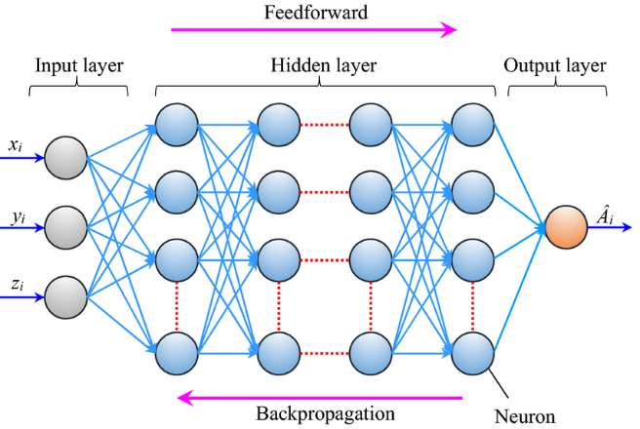

**Fig 2.1**

**2.2 YOLOv3: An Incremental Improvement**

**Author :** Redmon, J., & Farhadi, A.

**2.2.1 Algorithms Used**

**Darknet-53 Backbone:** YOLOv3 uses Darknet-53, a 53-layer convolutional neural network, as its backbone. This network is pre-trained on ImageNet, allowing it to perform feature extraction from images efficiently.

**2.2.2 Drawbacks**

**Lower Accuracy for Small Objects:** Although YOLOv3 performs better on smaller objects than its predecessors, its performance on very small objects is still not as accurate as models like Faster R-CNN or SSD. Small objects may be missed or poorly localized.

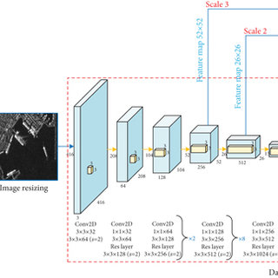

**Fig 2.2**

**2.3 ImageNet Classification with Deep Convolutional Neural Networks**

**Author :** Krizhevsky, A., Sutskever, I., & Hinton, G. E.

**2.3.1 Algorithms Used**

**Convolutional Neural Networks (CNNs):** A CNN is a type of deep neural network specifically designed for processing structured grid data like images. CNNs use convolutional layers to automatically extract features from raw image data.

**2.3.2 Drawbacks**

**Sensitivity to Hyperparameters:** AlexNet is very sensitive to hyperparameters like learning rate, batch size, and weight initialization.

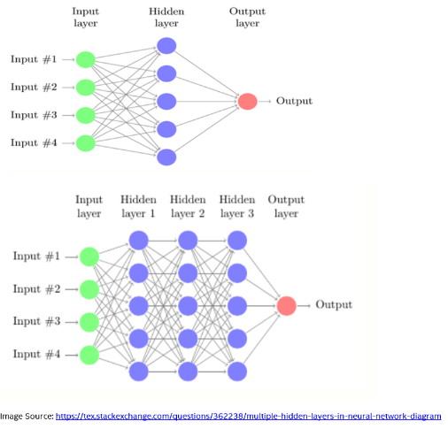

**Fig 2.3**

**2.4 RESEARCH GAPS OF EXISTING METHODS**

Despite significant advancements in the automation of agricultural product inspection, there remain several critical gaps in current research and implementation that hinder the full realization of its potential. These gaps, which affect the effectiveness, scalability, and widespread adoption of AI-driven inspection systems, must be addressed for the development of more comprehensive, efficient, and adaptable solutions in the agricultural sector. The key research gaps include:

**2.4.1 Adaptability to Diverse Products**

One of the most significant challenges faced by existing automated agricultural inspection systems is their lack of adaptability to diverse products. Many systems are designed to inspect a specific type of produce and are trained on datasets focused on particular product characteristics. For instance, a system designed to inspect apples may only be able to identify defects or quality issues specific to that fruit and may fail when presented with other types of produce, such as bananas, tomatoes, or avocados. This limits the scalability and flexibility of the inspection systems, as they require retraining or fine-tuning when applied to new types of products.

**2.4.2 Real-Time Processing**

Another pressing issue in current agricultural inspection systems is the challenge of real-time processing. Although many AI and machine vision-based systems have demonstrated high accuracy in detecting defects and assessing quality attributes, real-time processing remains a major limitation in high-speed production lines. In modern packing facilities, products are often processed in large volumes, with hundreds or even thousands of items passing through the inspection system every minute. The ability to analyze this large quantity of products in real-time is a significant challenge, particularly when considering the computational complexity of deep learning algorithms and image processing tasks.

**2.4.3 Comprehensive Quality Assessment**

Most existing automated inspection systems focus on one or two attributes of a product, such as color, size, or shape, but often fail to evaluate a product’s quality holistically by assessing multiple attributes simultaneously. For example, a common approach may involve assessing a fruit’s color to determine its ripeness, or its size to classify it for packaging. However, these assessments are often limited, and they overlook other critical quality factors like texture, uniformity, and defect detection (e.g., bruises, blemishes, or irregularities).

**2.4.4 Cost and Infrastructure**

Finally, cost and infrastructure remain significant barriers to the widespread adoption of automated inspection systems, especially in smaller agricultural operations. The initial setup costs for AI-driven systems can be prohibitively high, as they typically require specialized hardware (such as high-resolution cameras and powerful processing units), as well as custom software and algorithms tailored to specific products. These upfront costs can be a deterrent for small and medium-sized agricultural businesses that may not have the financial resources to invest in such systems.

In conclusion, while AI and image processing techniques have already made significant strides in the automated inspection of agricultural products, the above gaps must be addressed to create systems that are adaptable, fast, comprehensive, and cost-effective. Bridging these gaps will be key to developing scalable and widely adopted automated inspection systems in the agricultural sector, ultimately improving product quality, consistency, and operational efficiency across the industry.

**2.5 PROPOSED METHODOLOGY**

The proposed solution aims to create a real-time automated inspection system that uses AI and image processing techniques to analyze the color, ripeness, and uniformity of packed agricultural products. This system will be designed to be adaptable to different types of produce, providing a flexible solution that can be integrated into various agricultural packing lines.

**2.5.1 System Components:**

* **Image Acquisition:** High-resolution cameras will capture images of packed products on the production line.
* **Image Processing:** Advanced image processing algorithms will analyze product features such as color, shape, and texture.
* **AI Model:** A deep learning model (such as a Convolutional Neural Network) will be trained to identify quality attributes and classify products based on predefined standards.
* **Real-Time Feedback:** The system will provide immediate feedback to operators, alerting them to any quality issues in the packed products.
* **Integration with Existing Systems:** The solution will be designed to integrate smoothly with existing packing line setups.

**Table 2.5**

**System Components**

|  |  |  |
| --- | --- | --- |
| System Components | Description | Technologies/Methods |
| 1. Image Acquisition | Captures high-resolution images of packed agricultural products as they move along the production line. | - High-resolution cameras (e.g., 4K or higher)  - Controlled lighting (LED lightboxes, diffuse lighting)  - Camera synchronization with conveyor belts |
| 2. Image Processing | Analyzes product features such as color, shape, texture, and surface defects to assess product quality. | - Color analysis (RGB, HSV models)  - Shape detection (Edge detection, Contour analysis)  - Texture and surface defect analysis (Pattern recognition) |
| 3. AI Model (Deep Learning) | A deep learning model (e.g., CNN) used for classifying and assessing product quality attributes like color, ripeness, size, and uniformity based on predefined standards. | - Convolutional Neural Networks (CNNs)  - Transfer learning for adaptation to new products  - Continuous learning for model updates |
| 4. Real-Time Feedback | Provides immediate feedback to operators, alerting them to quality issues in real-time. Enables automated corrective actions. | - Visual (flashing lights) and auditory (alarms) alerts  - Automated sorting mechanisms (reject bins, robotic arms)  - Operator interface (dashboard) |
| 5. Integration with Existing Systems | Ensures seamless integration with current packing line infrastructure for smooth operation without significant modifications. | - Modular design  - API and communication protocols (e.g., RESTful API, Modbus)  - Scalability to handle varying production capacities  - Data logging and reporting systems |

**2.6 OBJECTIVES**

The primary objectives of this project focus on developing a robust, AI-powered image processing system to revolutionize the quality inspection of packed agricultural products. The system is designed to assess key attributes such as color, ripeness, and uniformity with high accuracy, ensuring that only products meeting quality standards reach consumers.

* + 1. **AI-Powered Inspection**: The project aims to create an advanced AI system capable of analyzing visual data from packed products, specifically evaluating color, ripeness, and uniformity. By automating this inspection, the system will be able to consistently assess these attributes, reducing human error and variation.
    2. **Improved Accuracy and Consistency**: By automating the inspection process, the system will significantly enhance the accuracy and consistency of quality assessments. This eliminates the subjective variability inherent in manual inspections, leading to more reliable results and fewer defects.
    3. **Real-Time Feedback**: The system will provide instant feedback to operators, allowing them to take corrective actions quickly. This real-time alert system ensures that issues like defects or irregularities are addressed immediately, preventing faulty products from advancing down the production line.
    4. **Scalability for High Volumes**: With automation, the system will be scalable to handle large volumes of products, allowing faster inspection and processing. This ensures that high-speed production lines can maintain quality control without sacrificing throughput, crucial in large-scale operations.
    5. **Cost-Effectiveness and Widespread Adoption**: The solution will be designed to be cost-effective, making it accessible for both large industrial operations and smaller agricultural businesses. By reducing the need for manual labor and minimizing errors, the system offers an affordable alternative to traditional quality assurance methods, promoting broader adoption across the industry.

**CHAPTER-3**

**SYSTEM ANALYSIS & DESIGN**

**3.1 System Architecture:** The proposed system will be built using the following key components:

* **Image Capture Module:** A set of high-quality cameras positioned at strategic points along the production line will capture images of the packed products. These cameras will be capable of taking clear, high-resolution images in varying lighting conditions.
* **Preprocessing Module:** Images will be preprocessed to remove noise, adjust lighting conditions, and enhance the visibility of key features such as color and texture.
* **Feature Extraction & Analysis:** Using image processing techniques such as edge detection, segmentation, and histogram analysis, the system will extract relevant features related to color, ripeness, and uniformity.
* **AI Model:** A deep learning model, specifically a Convolutional Neural Network (CNN), will be trained on a dataset of labeled images of various agricultural products to classify them based on quality attributes. The model will also be trained to detect defects or abnormalities in the products.
* **Real-Time Processing Module:** The system will be optimized to process images in real-time, providing instantaneous results to factory operators. Any products that do not meet the specified quality standards will be flagged for further inspection or removal.
* **Feedback System:** The system will generate visual or audio alerts to inform operators of any quality issues detected during the inspection.

**Overview**: Introduce the concept of the online inspection system. This system will inspect packed cases (e.g., cartons, boxes) to verify their integrity, labels, or contents.

**Objectives**:

* Automate the inspection process to reduce human errors.
* Improve efficiency and accuracy in detecting damaged or incorrectly packed items.
* Integrate real-time online inspection capabilities for remote monitoring.

**Scope**: Describe the boundaries of the project, i.e., it will focus on inspecting the packing quality, labels, and contents using image processing, machine learning, or sensor technologies.

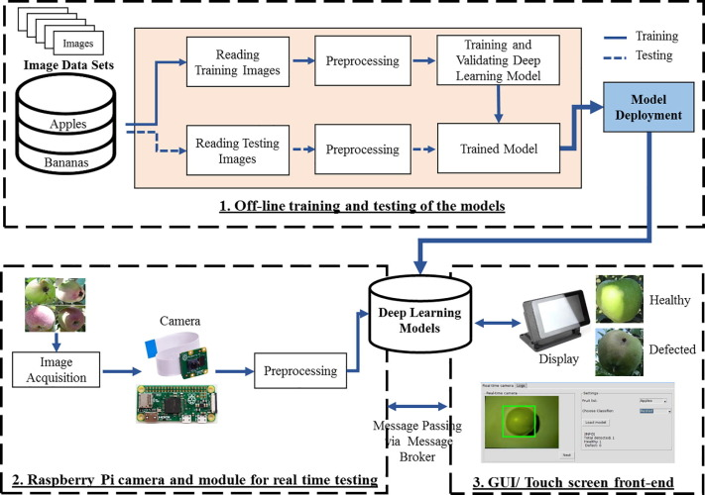

**Fig 3.1**

**System Design**

**Fig 3.2**

**Fruit Quality Monitoring**

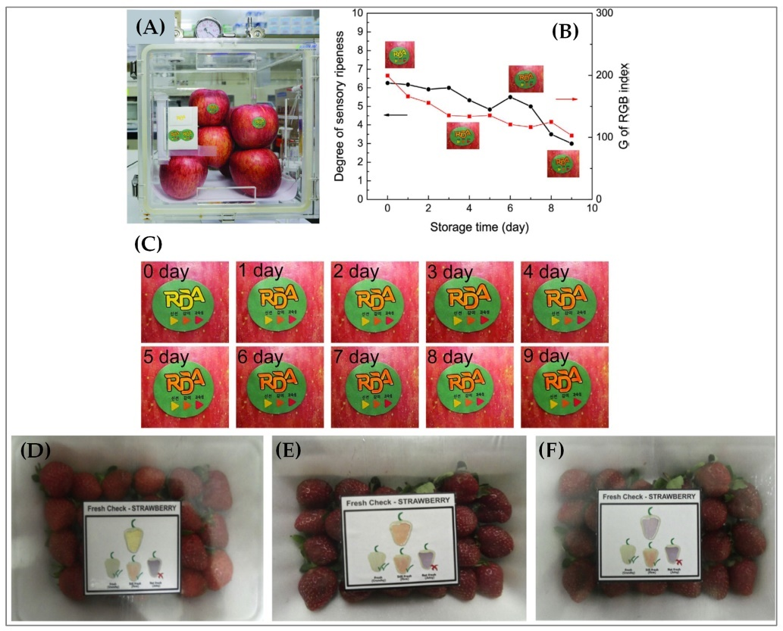

**3.2 Introduction**

* **Purpose**:
  + Introduce the **Online Inspection System** for packed cases, detailing how it automates the inspection of packaging quality, labels, and content using sensors, cameras, or machine vision technology.
  + Emphasize the goal of improving operational efficiency, accuracy, and the overall quality of the inspection process.
* **Background**:
  + Overview of manual packing and inspection challenges (human error, inefficiency, labor costs).
  + Benefits of an automated online system (increased speed, accuracy, cost savings).
* **System Objectives**:
  + Provide real-time inspection feedback to ensure packaging integrity.
  + Detect common defects like damages, missing labels, or incorrect contents.
  + Offer a scalable, reliable solution that can be deployed in various environments (factories, warehouses).
* **Scope**:
  + Define the scope, mentioning that this system focuses on real-time defect detection and inspection in packed cases, integrating with existing packing processes and systems.

**3.3 System Requirements**

* **Functional Requirements**:
  + **Image Capture**: Use cameras or sensors to capture images of packed cases.
  + **Image Processing**: Process the captured images to detect defects such as damaged packaging, missing items, or incorrect labeling.
  + **Inspection Results**: Provide pass/fail results, mark defects, and flag non-compliant cases.
  + **Real-time Feedback**: Display inspection results in real-time on the operator interface.
  + **Reports Generation**: Generate and store inspection reports, including case-specific details, timestamps, and operator actions.
* **Non-Functional Requirements**:
  + **Performance**: Must handle a high volume of cases (real-time processing for large-scale operations).
  + **Scalability**: The system must be able to scale up to accommodate more inspection points (e.g., more cameras).
  + **Reliability**: The system should provide 99% uptime, ensuring continuous operation.
  + **Security**: Data, including inspection results, must be securely transmitted and stored.

**3.4 System Architecture**

* **Overview**:
  + Detailed architecture of the system, focusing on the hardware and software components, interactions, and data flow.
* **Components**:
  + **Software**:
    - **Image Processing Software**: For image enhancement, defect detection, and analysis (e.g., OpenCV, TensorFlow).
    - **Database**: MySQL, PostgreSQL, or NoSQL for storing inspection logs and results.
    - **Frontend UI**: React, Angular, or any other suitable web framework.
    - **Backend**: Python, Node.js, or Java for backend processing.
  + **Integration**:
    - Integration with existing warehouse or packing systems for streamlined operations (e.g., ERP, SCM systems).
* **Data Flow Diagram (DFD)**:
  + Include a high-level DFD showing the flow of data between the sensors, processing unit, user interface, and data storage.

**3.5 Data Flow Diagram (DFD)**

* **Level 1 DFD**:
  + **External Entities**:
    - **Operator**: Receives inspection results and feedback.
    - **Sensors/Cameras**: Provide image data for inspection.
  + **Processes**:
    - **Image Capture**: Receives data from cameras and sends it for processing.
    - **Image Processing and Inspection**: Analyzes images, detects defects, and verifies labels.
    - **Report Generation**: Creates inspection reports.
  + **Data Stores**:
    - **Inspection Data Store**: Stores results and logs.
    - **Database**: Stores inspection history.

**3.6 Use Case Diagram**

* **Actors**:
  + **Operator**: Interacts with the system by reviewing real-time inspection results and reworking failed cases.
  + **System**: Automatically inspects, processes images, detects defects, and provides feedback.
  + **Administrator**: Manages the system, updates configurations, and monitors system performance.
* **Use Cases**:
  + **Capture Image**: Camera captures image of a packed case.
  + **Process Image**: System processes the captured image for defects.
  + **Generate Report**: The system generates inspection reports.
  + **View Results**: Operator views inspection results, receives feedback, and takes necessary actions.

**3.7 System Design**

* **Database Design:**
  + **Tables:**
    - Inspection Results: Stores data on each inspection (pass/fail, defects, timestamps).
    - Case Details: Stores details about each packed case (e.g., product type, customer ID).
    - Logs: Keeps track of operator activities, system errors, and maintenance actions.
  + **Data Relationships:**
    - Inspection Results is related to Case Details by case ID.
    - Logs are linked to inspection and operator actions for auditing.
* **User Interface Design:**
  + **Dashboard:** Displays the real-time inspection status (pass/fail).
  + **Reports Section:** Allows the operator to view historical results and detailed reports.
  + **Alerts:** Visual indicators for failed inspections, allowing the operator to take corrective action.

**3.8 Implementation Plan**

* **Development Phases**:
  + **Phase 1**: Requirement gathering, system design, and prototyping.
  + **Phase 2**: Hardware setup (cameras, sensors), database configuration, and software development (image processing).
  + **Phase 3**: Integration of image processing, backend development, and user interface.
  + **Phase 4**: System testing (unit, integration, and performance testing).
  + **Phase 5**: Deployment and user training, followed by ongoing maintenance.
* **Tools and Technologies**:
  + **Hardware**: High-resolution cameras, industrial sensors.
  + **Image Processing**: OpenCV for preprocessing, TensorFlow for defect detection.
  + **Backend**: Python, Flask/Django for backend services.
  + **Frontend**: React.js for dynamic user interface.
  + **Database**: MySQL/PostgreSQL for storing inspection data.
  + **Cloud**: AWS for scalability (EC2, S3), Lambda for serverless functions.

**3.9 Testing Strategy**

* **Unit Testing**:
  + Test each module (image capture, processing, report generation) independently.
* **Integration Testing**:
  + Ensure all modules work together seamlessly (e.g., image data flows correctly between sensors, processing, and the database).
* **System Testing**:
  + End-to-end testing of the entire system to ensure it functions as expected in real-world conditions.
* **Performance Testing**:
  + Test for latency and system response times under high volume, ensuring real-time processing.

**3.10 Deployment Plan**

* **Pre-Deployment**:
  + Perform final integration testing and user acceptance testing (UAT).
  + Train operators and administrators on using the system effectively.
* **Deployment**:
  + Roll out the system in stages, starting with one inspection line or process.
  + Monitor the system for issues and collect feedback from users.
* **Post-Deployment**:
  + Provide ongoing maintenance and support.
  + Implement updates based on feedback and evolving requirements.

**CHAPTER-4**

**IMPLEMENTATION**

The implementation of an online inspection system for packed cases involves various steps, from capturing images to processing and analyzing the data to providing feedback and generating reports. The system's goal is to automate the inspection of packed cases to detect defects such as damaged packaging, mislabels, or missing items. The implementation can be broken down into several phases, each of which will address a different aspect of the system.

**4.1 System Architecture**

The architecture will consist of the following components:

* **Cameras/Sensors**: Used for capturing high-quality images of packed cases.
* **Processing Unit**: A server or cloud-based system that processes the captured images using algorithms for defect detection and analysis.
* **User Interface (UI)**: A dashboard that displays real-time inspection results and alerts to operators.
* **Database**: Stores historical inspection data and logs.

**4.2 Image Processing and Defect Detection**

**4.2.1 Image Preprocessing**

* **Image Enhancement**: Techniques like histogram equalization or contrast adjustment to improve the quality of the image.
* **Noise Removal**: Using filters (e.g., Gaussian blur) to remove noise from the captured images.

**4.2.2 Feature Extraction**

* **Edge Detection**: Techniques like Canny edge detection can be used to find the edges of the packed case, helping identify packaging defects.
* **Pattern Recognition**: Using template matching or feature-based recognition to find labels or specific patterns on the packaging.

**4.2.3 Defect Detection**

* **Machine Learning**: Use pre-trained models (e.g., CNNs) to identify defects such as damaged packaging or missing labels.
  + **Label Detection**: Use Optical Character Recognition (OCR) to read and verify labels.
  + **Damage Detection**: Apply image segmentation to identify damaged areas on the packaging.

**4.2.4 Post-Processing**

* **Defect Classification**: Classify the defects based on their severity (e.g., minor vs. major).
* **Pass/Fail Criteria**: Define rules to determine whether a packed case passes or fails the inspection.

**4.3 Integration with the Backend**

**4.3.1 Backend System**

* **Image Analysis Module**: The core module that receives the captured images, processes them, and outputs inspection results.
* **Database Integration**: Store inspection results, timestamps, defect details, and operator actions in a relational or NoSQL database.

**4.3.2 Real-time Data Processing**

* **Processing Pipeline**: As images are captured, they are sent to the image processing unit (either on-premises or cloud) where the analysis takes place.
* **Real-time Feedback**: The results are sent back to the operator's interface immediately after processing, providing the pass/fail status.

**4.4 User Interface Design**

**4.4.1 Dashboard**

* **Real-time Monitoring**: Display the inspection status of cases as they move down the production line.
* **Alerts**: Show visual cues (e.g., red flags) when a case fails inspection, including details of the detected defect (e.g., "damaged box", "label mismatch").

**4.4.2 Report Generation**

* **Inspection Logs**: Allow operators to access logs of past inspections.
* **Defect History**: Provide historical data about defects for analysis and process improvements.

**4.4.3 Operator Interaction**

* **Manual Override**: In case of a failed inspection, the operator can inspect the case manually and override the system’s decision if necessary.
* **Rework Suggestions**: Suggest corrective actions for failed cases.

**PSEUDOCODE:**

def analyze_apple(image_path):

    """Analyze the uploaded image and return the analysis results for apples."""

    # Load the image

    image = cv2.imread(image_path)

    if image is None:

        return {"status": "Image not found"}

    # Convert to RGB and HSV color spaces

image_rgb = cv2.cvtColor(image, cv2.COLOR_BGR2RGB)

hsv_image = cv2.cvtColor(image, cv2.COLOR_BGR2HSV)

# Define color ranges for ripe (red), unripe (green), and damaged (black) apples

lower_red = np.array([0, 70, 50])      # Adjusted for ripe apples

upper_red = np.array([10, 255, 255])

lower_green = np.array([35, 50, 50])   # Adjusted for unripe apples

upper_green = np.array([85, 255, 255])

lower_black = np.array([0, 0, 0])      # Adjusted for damaged apples (dark/black)

    upper_black = np.array([50, 50, 50])

    # Create masks for ripe (red), unripe (green), and damaged (black) apples

    red_mask = cv2.inRange(hsv_image, lower_red, upper_red)

    green_mask = cv2.inRange(hsv_image, lower_green, upper_green)

    black_mask = cv2.inRange(hsv_image, lower_black, upper_black)

    # Calculate the percentage of red, green, and black pixels in the image

    red_percentage = np.sum(red_mask) / (image.shape[0] * image.shape[1]) * 100

green_percentage = np.sum(green_mask) / (image.shape[0] * image.shape[1]) * 100

    black_percentage = np.sum(black_mask) / (image.shape[0] * image.shape[1]) * 100

    # Analyze color and ripeness based on thresholds

    if red_percentage > 50:

        color_status = "Red"

        ripeness_status = "Ripe"

    elif green_percentage > 50:

        color_status = "Green"

        ripeness_status = "Unripe"

    elif black_percentage > 0:

        color_status = "Black"

        ripeness_status = "Ripe"  # Considered ripe but bad due to damage

    else:

        color_status = "Unknown"

        ripeness_status = "Unknown"

# Analyze overall status

    if black_percentage > 20:

        overall_status = "Bad"

    elif ripeness_status == "Ripe" and color_status == "Red":

        overall_status = "Good"

    elif ripeness_status == "Unripe" and color_status == "Green":

        overall_status = "Good"

    else:

        overall_status = "Bad“

result = {

'color_check': 'True',

        'ripeness_check': 'True',

        'uniformity_check': 'True',

        'color_status': color_status,

        'ripeness_status': ripeness_status,

        'overall_status': overall_status }

return result

def submit_feedback(request):

    if request.method == 'POST':

        form = FeedbackForm(request.POST)

        image_name = request.POST.get('image_name')  # Retrieve image name

        if form.is_valid():

            feedback_value = form.cleaned_data['feedback']

            # Save the feedback to the database

    Feedback.objects.create(image_name=image_name, feedback=feedback_value)

# Show a response based on feedback

            if feedback_value == 'yes':

                response_message = "Thank you for your feedback! We're glad you found it helpful."

            else:

                response_message = "Oops! We'll learn from this and strive to improve."

            return render(request, 'inspection/thank_you.html', {

                'response_message': response_message,

                'image_name': image_name

            })

    return redirect('upload_image')

def analyze_images(image_paths, fruit_type=""):

    """Analyze a list of images and return their results for the specified fruit type."""

    results = []

    for image_path in image_paths:

        if fruit_type == "apple":

            result = analyze_apple(image_path)

        else:

            result = {"status": "Unknown fruit type"}

        print(f"Result for {image_path}: {result}")

        results.append(result)

    return results

# Example usage for analyzing multiple images of all fruits

apple_image_paths = [

r"C:\Users\user\Documents\Dataset\train\Apples\ripe\Apples ripe\image_13.jpg",  # Replace with actual image paths

r"C:\Users\user\Documents\Dataset\train\Apples\unripe\Apples unripe\image_1.jpg"

]

# Analyze the images and print the results for apples

print("Apple Analysis Results:")

apple_results = analyze_images(apple_image_paths, fruit_type="apple")

for result in apple_results:

    print(result)

def analyze_apple(image_path):

    """Analyze the uploaded image and return the analysis results for apples."""

    # Load the image

    image = cv2.imread(image_path)

    if image is None:

        return {"status": "Image not found"}

    # Convert to RGB and HSV color spaces

image_rgb = cv2.cvtColor(image, cv2.COLOR_BGR2RGB)

hsv_image = cv2.cvtColor(image, cv2.COLOR_BGR2HSV)

# Define color ranges for ripe (red), unripe (green), and damaged (black) apples

lower_red = np.array([0, 70, 50])      # Adjusted for ripe apples

upper_red = np.array([10, 255, 255])

lower_green = np.array([35, 50, 50])   # Adjusted for unripe apples

upper_green = np.array([85, 255, 255])

green_percentage = np.sum(green_mask) / (image.shape[0] * image.shape[1]) * 100

black_percentage = np.sum(black_mask) / (image.shape[0] * image.shape[1]) * 100

# Analyze color and ripeness based on thresholds

    if red_percentage > 50:

        color_status = "Red"

        ripeness_status = "Ripe"

    elif green_percentage > 50:

        color_status = "Green"

        ripeness_status = "Unripe"

    elif black_percentage > 0:

        color_status = "Black"

        ripeness_status = "Ripe"  # Considered ripe but bad due to damage

    else:

        color_status = "Unknown"

        ripeness_status = "Unknown"

def submit_feedback(request):

    if request.method == 'POST':

        form = FeedbackForm(request.POST)

        image_name = request.POST.get('image_name')  # Retrieve image name

        if form.is_valid():

            feedback_value = form.cleaned_data['feedback']

            # Save the feedback to the database

   Feedback.objects.create(image_name=image_name, feedback=feedback_value)

# Example usage for analyzing multiple images of all fruits

apple_image_paths = [

r"C:\Users\user\Documents\Dataset\train\Apples\ripe\Apples ripe\image_13.jpg",  # Replace with actual image paths

r"C:\Users\user\Documents\Dataset\train\Apples\unripe\Apples unripe\image_1.jpg"

]

# Analyze the images and print the results for apples

print("Apple Analysis Results:")

apple_results = analyze_images(apple_image_paths, fruit_type="apple")

for result in apple_results:

    print(result)

**Role of Convolutional Neural Networks (CNN) in the Implementation of Online Inspection of Packed Cases**

Convolutional Neural Networks (CNNs) play a crucial role in the implementation of online inspection systems for packed cases, especially when it comes to automating the visual inspection process. Their ability to automatically learn spatial hierarchies in images makes them highly effective for tasks such as defect detection, object recognition, and image classification.

Here’s a breakdown of the role of CNNs in this implementation:

**4.5 Image Preprocessing and Feature Extraction**

CNNs are designed to automatically extract important features from raw image data, which is vital in an online inspection system where real-time processing of images is required.

**Role:**

* **Automatic Feature Extraction**: CNNs automatically detect and extract features such as edges, textures, shapes, and patterns in the images of packed cases. This is particularly useful in identifying defects like damaged packaging, incorrect labeling, or missing items.
* **Reduction in Manual Feature Engineering**: Unlike traditional image processing techniques, where manual feature extraction (e.g., edge detection, thresholding) is needed, CNNs learn to identify the most relevant features on their own, improving efficiency and accuracy.

**4.6 Defect Detection**

The primary goal of the online inspection system is to detect defects such as packaging damages, label mismatches, and incomplete packing. CNNs can classify and localize defects in images with high accuracy.

**Role:**

* **Defect Classification**: CNNs can be trained to classify whether a packed case is defective or non-defective. For example, by learning from a labeled dataset (images of packed cases), the CNN can be trained to recognize various types of defects, such as wrinkles in packaging, incorrect labels, or missing products.
* **Localization of Defects**: Through advanced techniques such as Region-based CNNs (R-CNN), CNNs can not only classify defects but also localize them, indicating the exact location of the defect within the packed case image. This feature is important for operators, who can take action based on the specific area that requires attention (e.g., relabeling or repacking).

**4.7 Label Verification**

Labeling is an important part of the packing process. A significant part of online inspection involves verifying whether the labels on packed cases are correct, clear, and readable.

**Role:**

* **Text Recognition (OCR)**: CNNs, combined with Optical Character Recognition (OCR) models, are capable of verifying the labels on packed cases. The CNN processes the image of the case and extracts the text on the label. OCR helps in verifying that the correct information, such as product details or barcodes, is present and legible.
* **Error Detection**: CNNs can flag cases where labels are missing, misprinted, or misaligned, helping to maintain accuracy in the packing and shipping process.

**4.8 Handling Variability in Packed Cases**

Packed cases may come in various shapes, sizes, colors, and packaging types, which can make manual inspection difficult and prone to error. CNNs, due to their robustness, can handle this variability effectively.

**Role:**

* **Generalization Across Different Case Types**: Once trained on a diverse set of images, CNNs can generalize across different types of cases and products, reducing the need for manual adjustments or reconfigurations of the inspection system.
* **Adaptation to New Defects**: CNNs can be retrained or fine-tuned to adapt to new types of defects or packaging materials, making the system scalable as new products or packaging methods are introduced.

**4.9 Real-Time Processing for High-Throughput Environments**

Online inspection systems must be capable of processing images in real-time, especially in high-throughput environments such as manufacturing or packaging lines. CNNs can be optimized to deliver rapid results, making them suitable for such applications.

**Role:**

* **Efficient Processing**: With modern hardware accelerators such as GPUs, CNNs can process images quickly, ensuring that inspection results are provided almost instantaneously (within milliseconds or seconds per image). This is crucial in a fast-paced production environment where high volumes of packed cases need to be inspected without slowing down the production line.
* **Scalability**: CNN models can be scaled to handle a growing number of inspection points (e.g., more cameras on a production line) by distributing the computation across multiple servers or GPUs, ensuring that the system remains fast and reliable as the system expands.

**4.10 Model Training and Continuous Improvement**

A CNN-based system's effectiveness depends on the quality and quantity of the data used for training. During the implementation of the inspection system, CNNs undergo training and can continuously improve over time.

**Role:**

* **Training on Labeled Data**: The CNN is initially trained using a large dataset of labeled images, where packed cases are marked as defective or non-defective, and defects are categorized. This process involves using supervised learning techniques to help the model understand the features that correlate with defects.
* **Continuous Learning**: As new defect types or changes in the packing process arise, CNNs can be retrained with new data, allowing the system to learn and adapt to new conditions, thereby improving its detection accuracy over time.

**4.11 Integration with the Full Inspection Pipeline**

The CNN model is just one part of a full online inspection system. CNNs integrate with other components like cameras, sensors, processing units, and the user interface.

**Role:**

* **Input to the Inspection System**: The CNN receives image data from the cameras or sensors, processes it, and outputs the results (defective/non-defective) along with any detected defects.
* **Real-Time Feedback and Reporting**: The results from the CNN are used to generate real-time feedback for operators, guiding them on whether the packed case is approved or needs rework.
* **Post-Processing and Reporting**: Based on the CNN’s output, the inspection system generates detailed reports about defects, including location, severity, and type, which are stored in a database for future reference.

**Example Workflow:**

1. **Image Capture**: A camera captures an image of a packed case moving along a conveyor.
2. **CNN Processing**: The image is sent to the CNN for analysis. The CNN detects features like packaging damage, missing labels, or incorrect text.
3. **Defect Detection**: The CNN classifies the packed case as defective or non-defective, and, if applicable, locates the specific defect within the image.
4. **Real-Time Feedback**: The system sends the result (pass/fail) to the operator interface, with details of the defect (e.g., damaged box, incorrect label).
5. **Report Generation**: The results, along with timestamps and other metadata, are saved in the database for later analysis and tracking.

**CHAPTER-5**

**TESTING**

Testing is a crucial part of implementing the online inspection system for packed cases. It ensures that the system operates effectively, accurately detects defects, and provides real-time feedback. A well-structured testing phase is vital for identifying potential issues and improving the overall quality of the system. Below is a comprehensive testing strategy that includes different types of tests for the online inspection system.

**5.1 Types of Testing for the Online Inspection System**

5.1.1 Unit Testing

5.1.2 Integration Testing

5.1.3 System Testing

5.1.4 Performance Testing

5.1.5 Accuracy Testing

5.1.6 User Acceptance Testing (UAT)

5.1.7 Security Testing

5.1.8 Regression Testing

**5.1.1 Unit Testing**

Unit testing focuses on testing individual components of the online inspection system, such as image preprocessing, defect detection algorithms, and database interactions.

**Key Areas to Test:**

**Image Preprocessing:** Verify that operations like noise removal, contrast adjustment, and edge detection work correctly on sample images.

**Defect Detection Algorithms:** Ensure that defect detection algorithms (e.g., CNNs) correctly classify images as defective or non-defective, with expected outputs on a set of test cases.

**Database Operations:** Test the functionality of inserting, updating, and retrieving inspection results from the database.

**Testing Tools:**

* JUnit (for Java-based components)
* PyTest (for Python-based modules)
* Mocking frameworks like Mockito for simulating database interactions.

**5.1.2 Integration Testing**

Integration testing ensures that different components of the system work together as expected. This includes testing the interaction between the camera system, image processing unit, database, and user interface.

**Key Areas to Test:**

* Camera Integration: Test if the camera feeds are successfully captured and sent to the image processing system in real time.
* Data Flow: Ensure that the results from the image processing module are accurately reflected in the database and user interface.
* Real-Time Feedback: Verify that inspection results are promptly communicated to the user interface and that operators receive timely feedback on the status of each packed case.

**Testing Tools:**

* Postman for testing API interactions between components.
* Selenium for testing web-based user interfaces.
* Docker for simulating various environments and ensuring integration between components.

**5.1.3 System Testing**

System testing focuses on testing the complete end-to-end functionality of the entire online inspection system, including hardware and software components.

**Key Areas to Test:**

* End-to-End Inspection Process: Verify that a packed case is captured, processed for defects, and passed or failed based on inspection results.
* Operator Feedback: Ensure that operators can see real-time inspection results on the dashboard, and alerts are generated for failed inspections.
* Reporting: Test the system’s ability to generate accurate reports and logs of inspection results.
* Scalability: Test if the system can handle an increased load (more cameras or higher throughput of packed cases).

**Testing Tools:**

* Selenium for end-to-end UI testing.
* Load testing tools like Apache JMeter for scalability testing.
* Jenkins for continuous integration and running system tests automatically.

**5.1.4 Performance Testing**

Performance testing assesses how well the online inspection system performs under different loads, ensuring that the system can handle the required processing speed and throughput.

**Key Areas to Test:**

* Throughput: Ensure the system can process images quickly and continuously at the required rate (e.g., 100 cases per minute).
* Latency: Measure the time it takes from image capture to feedback (i.e., how quickly the system processes an image and provides feedback).
* System Resource Usage: Monitor CPU and memory usage to ensure that the system is resource-efficient, especially during high-load periods.

**Testing Tools:**

* Apache JMeter for load testing.
* Gatling for performance testing on RESTful APIs.
* Profilers like YourKit for monitoring resource usage during testing.

**5.1.5 Accuracy Testing**

Accuracy testing focuses on verifying the effectiveness of the defect detection system, especially the convolutional neural network (CNN) model used for defect identification.

**Key Areas to Test:**

* False Positive Rate: Check the rate at which the system incorrectly flags a packed case as defective when it is not.
* False Negative Rate: Ensure that the system does not miss any actual defects (i.e., failing to detect a defective packed case).
* Precision and Recall: Evaluate the precision (correctly identified defects vs. total detected defects) and recall (correctly identified defects vs. total actual defects) of the defect detection model.
* Generalization: Test the model on a variety of test cases, including edge cases like unusual packing materials or lighting conditions.

**Testing Tools:**

* Confusion Matrix for evaluating model accuracy.
* TensorFlow or PyTorch for evaluating deep learning models and their performance metrics.

**5.1.6 User Acceptance Testing (UAT)**

UAT is conducted by end-users (operators) to ensure that the system meets their requirements and expectations in a real-world setting.

**Key Areas to Test:**

* Ease of Use: Verify that operators can easily understand and use the system, including accessing inspection reports and interpreting the results.
* Real-Time Feedback: Ensure that operators receive immediate feedback on whether a packed case passes or fails the inspection.
* Manual Override: Test the system’s ability to allow manual intervention when needed, such as overriding a failed inspection.

**Testing Tools:**

* User feedback through surveys and observations during testing.
* Screen recording tools to capture operator interactions with the system for analysis.

**5.1.7 Security Testing**

Security testing ensures that the system is secure and protected from potential vulnerabilities, especially regarding the storage of inspection data and user access.

**Key Areas to Test:**

* Data Privacy: Ensure that inspection data is encrypted both in transit (using protocols like TLS/SSL) and at rest (in databases).
* Access Control: Verify that only authorized personnel can access the system, using authentication and role-based access controls.
* Vulnerability Scanning: Perform penetration testing to check for security weaknesses that could be exploited.

**Testing Tools:**

* OWASP ZAP for security vulnerability scanning.
* Burp Suite for penetration testing.

**5.1.8 Regression Testing**

Regression testing ensures that changes or updates to the system (e.g., software updates, model retraining) do not introduce new bugs or break existing functionality.

**Key Areas to Test:**

* Bug Fixes: Test if previously identified bugs or issues have been resolved.
* New Features: Ensure that newly added features (e.g., an updated defect detection model or UI enhancement) work as intended without affecting existing functionalities.

**Testing Tools:**

* Selenium for automated UI regression testing.
* JUnit/PyTest for testing back-end components.

**CHAPTER-6**

**CONCLUSION**

The integration of Artificial Intelligence (AI) and image processing into the inspection process of packed agricultural products presents a transformative opportunity for the agricultural industry. By automating the quality control process, AI-driven systems can significantly enhance the accuracy, consistency, and efficiency of inspections, addressing many of the limitations associated with manual inspection methods. These advancements contribute directly to improving product quality and customer satisfaction, key factors in today’s competitive market.

However, the successful deployment and operation of this technology extend beyond the technical aspects of system design and implementation. Several critical considerations must be taken into account to ensure the system’s effectiveness and sustainability. These include ethical concerns, regulatory requirements, the infrastructure needed to support AI systems, cost factors, and the impact on the workforce. Each of these factors plays a pivotal role in determining the feasibility and long-term success of AI-powered automation in agricultural operations.

**Ethical and Regulatory Considerations**

The use of AI in agriculture must be aligned with ethical standards and regulatory frameworks, particularly in relation to data privacy, product safety, and transparency. For instance, the AI system’s decision-making process needs to be transparent to ensure fairness and accountability in product classification. Furthermore, adherence to regulatory guidelines set by food safety organizations must be maintained, ensuring that the system does not compromise consumer health or safety. These ethical and regulatory aspects are essential to maintaining consumer trust and ensuring the system’s long-term viability in the marketplace.

**Infrastructure and Cost Considerations**

The deployment of an AI-based inspection system requires significant investment in both infrastructure and technology. High-resolution cameras, specialized lighting, and robust computing power are necessary components for capturing and processing real-time product data. While these costs may present a barrier for smaller operations, the long-term benefits, such as improved efficiency and reduced labor costs, can offset these initial investments. Additionally, the scalability of AI systems means that even smaller businesses can gradually adopt automation technologies as they grow, making this innovation accessible across different business sizes.

**Workforce Impact**

The shift towards automation also raises important questions about the impact on the workforce. While AI can reduce the need for manual labor in quality inspection tasks, it is essential to ensure that workers are adequately retrained to handle new roles that emerge as a result of automation. This may involve transitioning workers into more value-added positions, such as overseeing AI system operations, performing maintenance, and managing data analytics. Managing this workforce transition thoughtfully can mitigate potential job displacement concerns and empower employees to leverage new technologies.

**Future Outlook**

By carefully managing these considerations, businesses can achieve a harmonious integration of AI into their quality control processes. The potential benefits of this integration—greater accuracy, scalability, and efficiency—will not only streamline operations but also improve the quality of agricultural products and customer satisfaction. Moreover, the use of AI can contribute to more sustainable and resilient agricultural systems by reducing waste, improving production standards, and enhancing the traceability of products.

As the technology continues to evolve, the agricultural industry stands poised to benefit from ongoing advancements in AI and image processing, making it an exciting time for innovation in quality control. The path forward will require collaboration between industry stakeholders, policymakers, and technology providers to ensure that these systems are deployed responsibly and effectively, maximizing their impact on both business outcomes and consumer experiences.

In conclusion, the integration of AI and image processing technologies in the agricultural sector promises substantial improvements in quality control, productivity, and customer satisfaction. By addressing the accompanying challenges thoughtfully, businesses can harness these technologies to unlock new levels of performance and create a more efficient and sustainable future for agricultural operations worldwide.

**REFERENCES**

* Russakovsky, O., Deng, J., Su, H., et al. (2015). "ImageNet Large Scale Visual Recognition Challenge." *International Journal of Computer Vision*, 115(3), 211-252.
* **LeCun, Y., Bengio, Y., & Hinton, G. (2015).** "Deep Learning." Nature, 521(7553), 436-444.
* **Zhang, X., Li, Z., and Cai, Y. (2019).** "Image Processing Techniques for Quality Inspection in Manufacturing." IEEE Transactions on Industrial Electronics, 66(7), 5079-5090.
* **Redmon, J., Divvala, S., Girshick, R., & Farhadi, A. (2016).** "You Only Look Once: Unified, Real-Time Object Detection." Proceedings of the IEEE Conference on Computer Vision and Pattern Recognition (CVPR).
* **Zhou, Z., Sohn, S., & Peng, Y. (2021).** "Real-Time Edge AI for Industrial Quality Inspection." IEEE Internet of Things Journal, 8(9), 7012-7024.
* ISO 9001:2015 Quality Management Systems – Requirements.
* **Goodfellow, I., Bengio, Y., & Courville, A. (2016).** "Deep Learning." MIT Press.
* **Nguyen, H., Valiveti, S., and Ramachandran, S. (2020).** "AI in Quality Control: Industrial Applications and Case Studies." Journal of Manufacturing Systems, 57, 366-380.
* **Regattieri, A., Gamberi, M., & Manzini, R. (2007).** "Traceability of Food Products: General Framework and Experimental Evidence." Journal of Food Engineering.

**APPENDIX-A**

**Step 1: analyze_apple(image_path) :**

* Loads the image from the given image_path using OpenCV.
* Converts the image from BGR to RGB and HSV color spaces for further processing.
* These masks isolate the pixels in the image that fall within the specified color ranges.

**Step 2: Forms :**

* Calculates the percentage of red, green, and black pixels in the image.
* Based on the color percentage thresholds, it assigns a color_status and

ripeness_status.

* Determines if the apple is good or bad based on ripeness and damage.
* Returns a dictionary with the analysis results.

**Step 3: Submit Feedback :**

* Handle file uploads, specifically images, from a user.
* Temporarily store the uploaded image on the server using Django's default storage system.
* Pass the saved image to an analysis function (analyze_apple) for further processing (such as fruit quality detection).

**Step 4: Example Usage :**

* These paths represent images of apples (both ripe and unripe).
* This section of the code runs the analysis on the specified apple images and prints the results.
* Renders the thank-you page with the appropriate message.
* The code handles image upload and analysis for apples by detecting their color and determining their ripeness and overall quality.
* The feedback system lets users give feedback on the results, and the system responds accordingly.

**SCREENSHOTS**

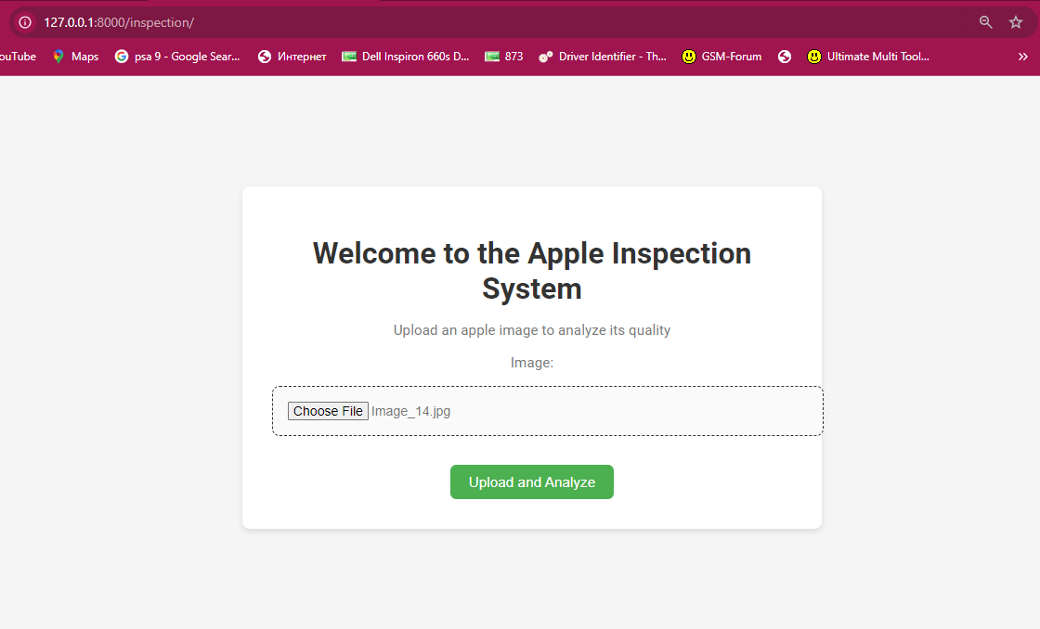

Figure 9.1

Application Interface

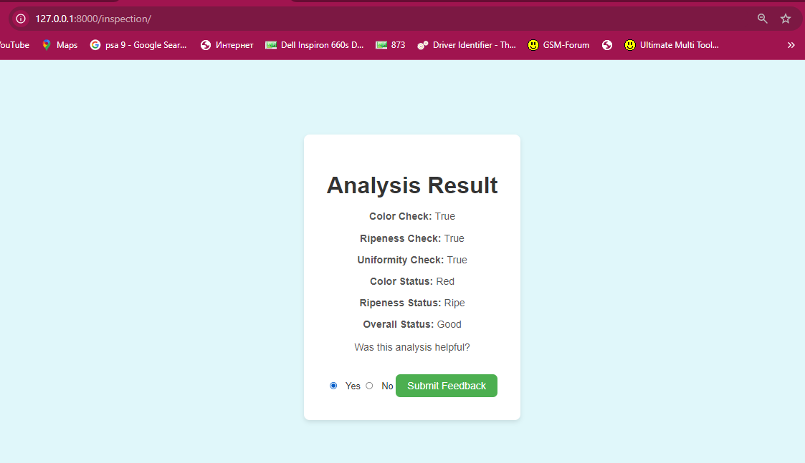

Figure 9.2

Analysis Result

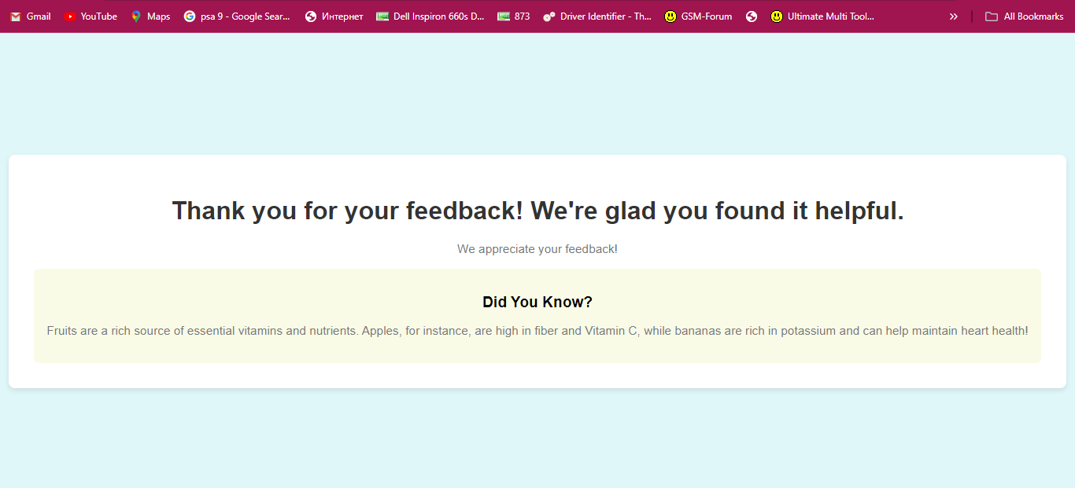

Figure 9.3

Feedback

